10. Closest Pair of Points – Brute Force
Aim
To find the closest pair of points using the Brute Force algorithm.
Algorithm
- Start.
- Initialize a set of points.
- Calculate the Euclidean distance between every pair of points.
- Find the minimum distance.
- Display the closest pair and their distance.
- Stop.
Procedure
- Define a list of points using their x and y coordinates.
- Compare every possible pair of points.
- Calculate the distance between each pair using the Euclidean distance formula.
- Update the minimum distance whenever a smaller distance is found.
- Print the closest pair and minimum distance.
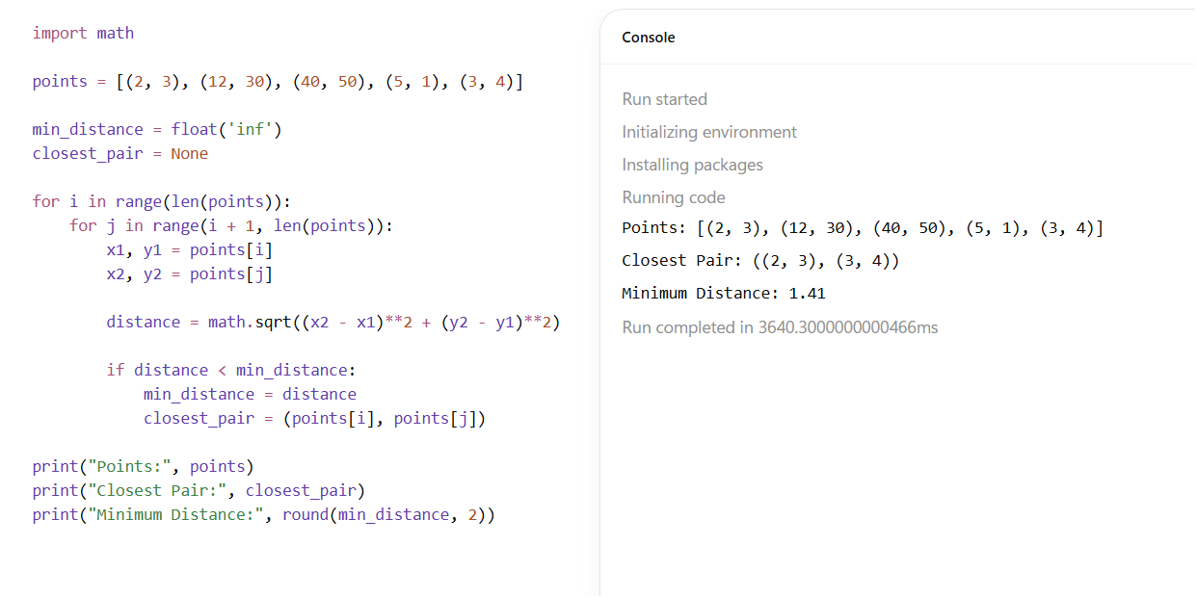
Result
The closest pair of points was successfully identified using the Brute Force algorithm.

